**DDL (DATA DEFINITION LANGUAGE):**

DDL, or Data Definition Language, is a subset of SQL (Structured Query Language) used to define and manage the structure of a database, including tables, schema, and constraints. The primary commands that fall under DDL are:

* CREATE
* ALTER
* DROP

CREATE: This command is used to create database objects like tables, indexes, views, and stored procedures.

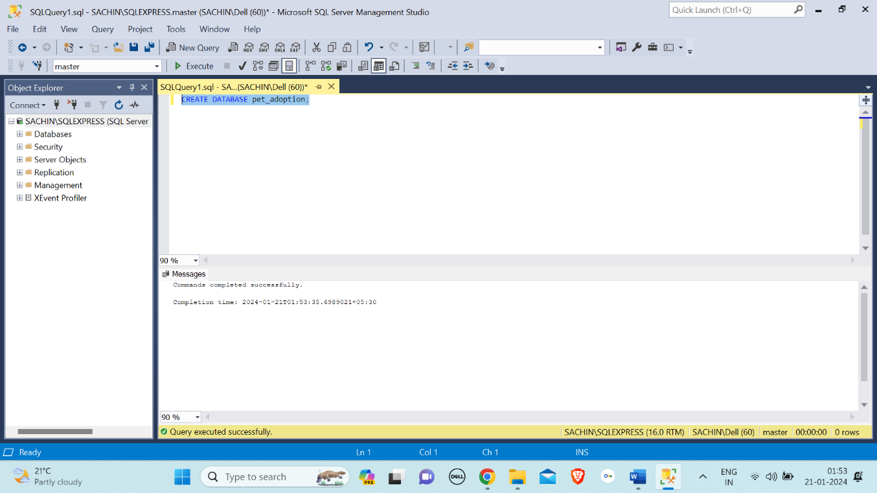

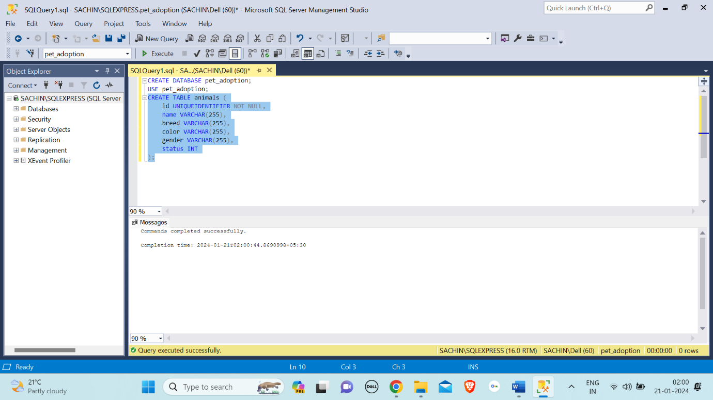

ALTER: The "ALTER" command in SQL is used to modify the structure of existing database objects, such as tables, by adding, modifying, or dropping columns or constraints.

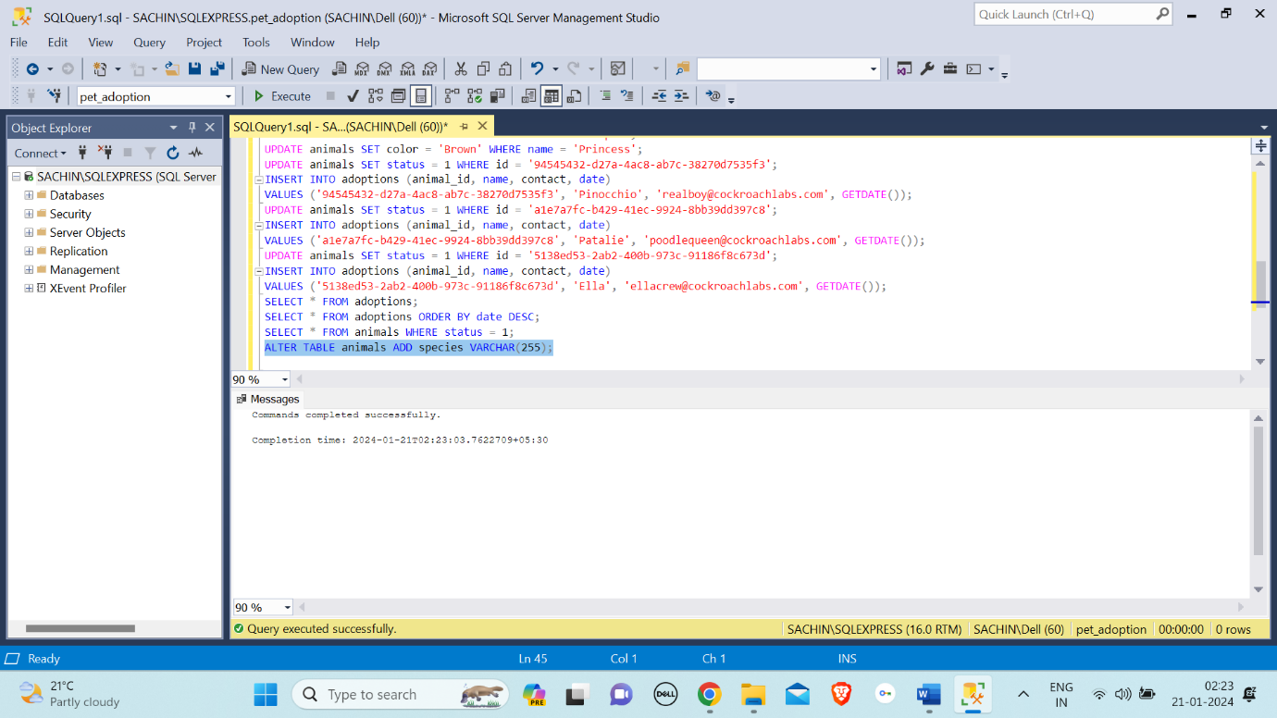

DROP: The "DROP" command in SQL is used to delete or remove a database object, such as a table, view, index, or schema.

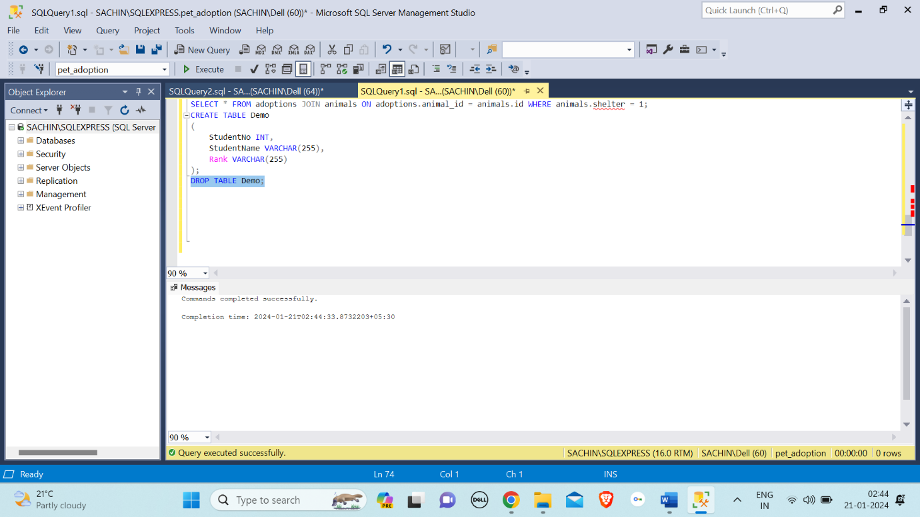

**DML (DATA MANIPULATION LANGUAGE):**

DML, or Data Manipulation Language, consists of a set of SQL commands that allow users to manipulate data stored in a database. The primary DML commands include:

* SELECT
* INSERT
* UPDATE
* USE

SELECT: The "SELECT" command in SQL is used to retrieve data from one or more tables in a database.

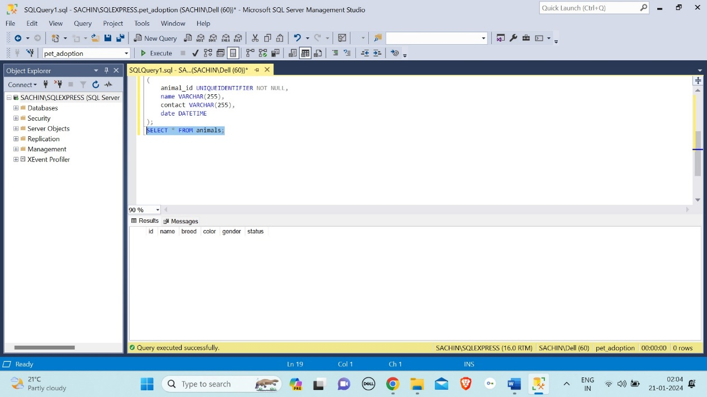

INSERT: The "INSERT" command in SQL is used to add new records (rows) into a table.

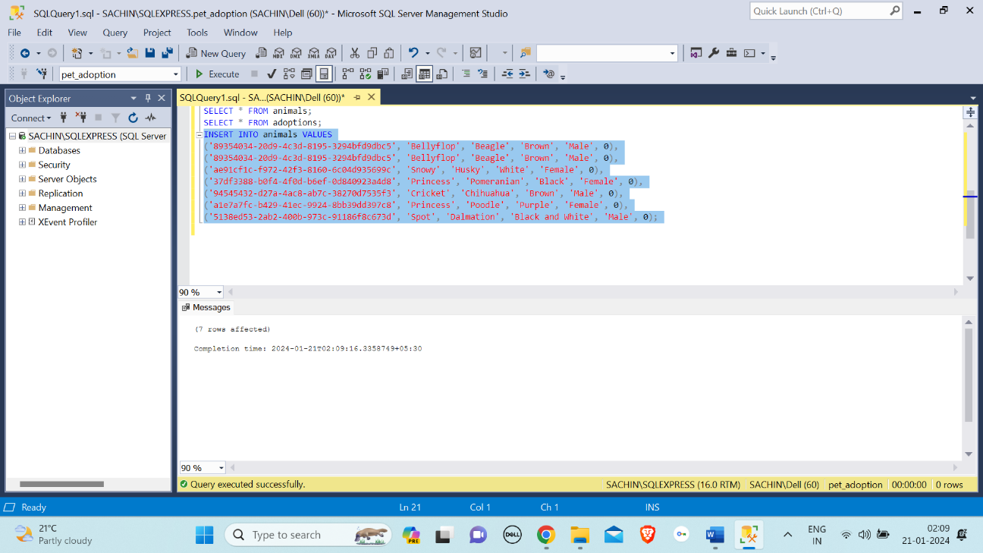

UPDATE: The "UPDATE" command in SQL is used to modify existing records in a table by changing the values of specified columns based on a specified condition.

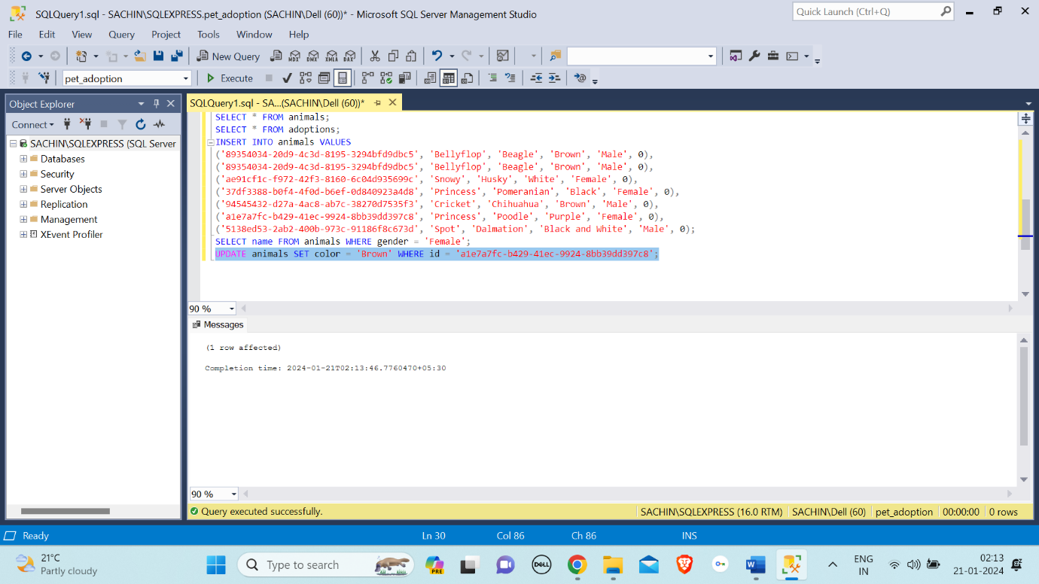

USE: The "USE" command in SQL is used to set the current database context, specifying the database on which subsequent queries and operations will be performed.

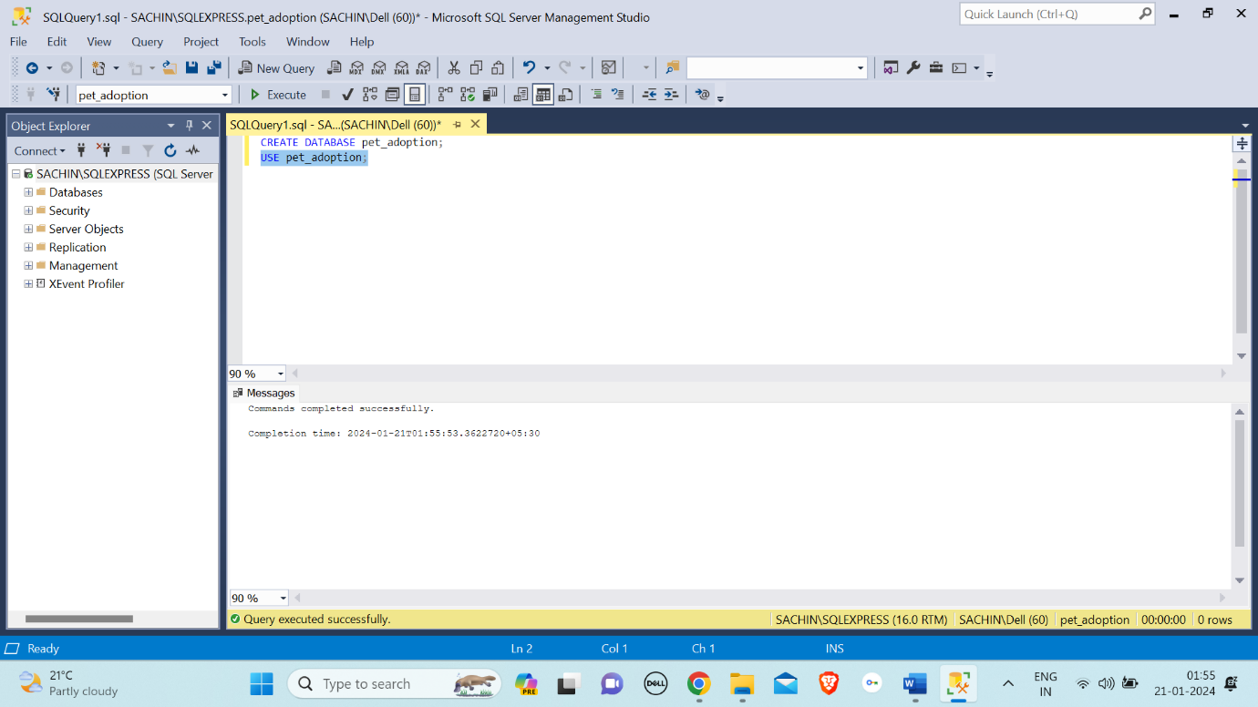

**JOINS:**

SQL Join statement is used to combine data or rows from two or more tables based on a common field between them. Different types of Joins are as follows:

* INNER JOIN
* LEFT JOIN
* RIGHT JOIN
* FULL JOIN

Inner Join: Returns only the rows that have matching values in both tables.

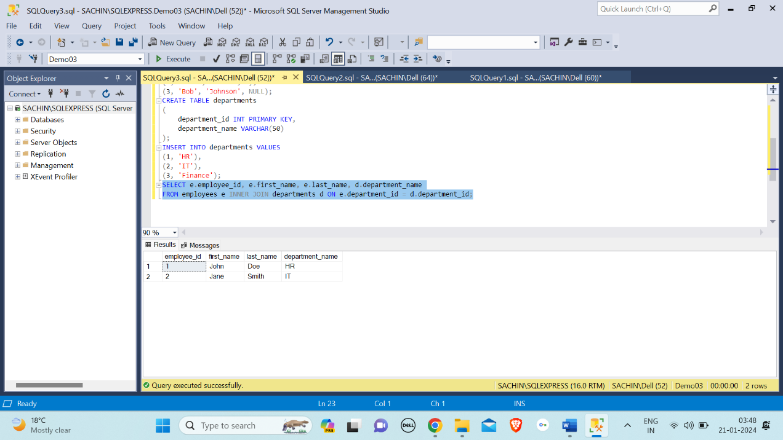

Left Join (or Left Outer Join): Returns all rows from the left table and the matched rows from the right table. If there is no match, NULL values are returned for columns from the right table.

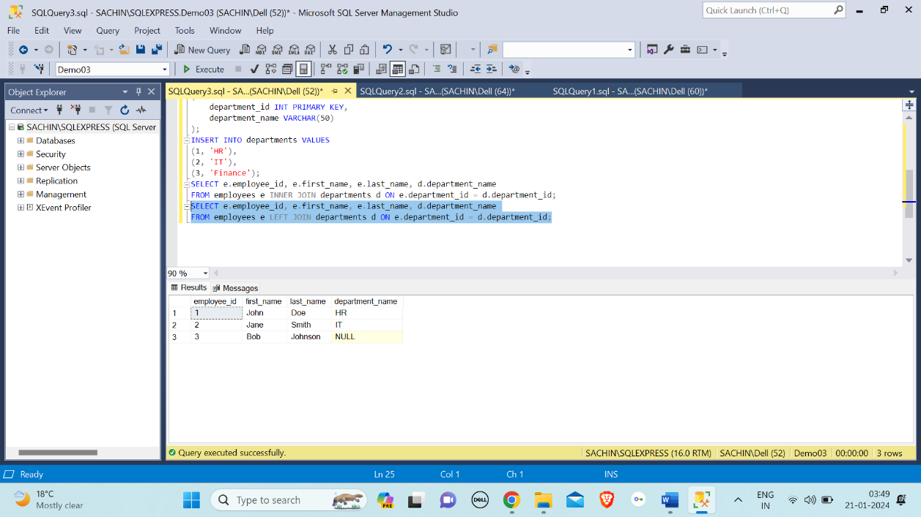

Right Join (or Right Outer Join): Returns all rows from the right table and the matched rows from the left table. If there is no match, NULL values are returned for columns from the left table.

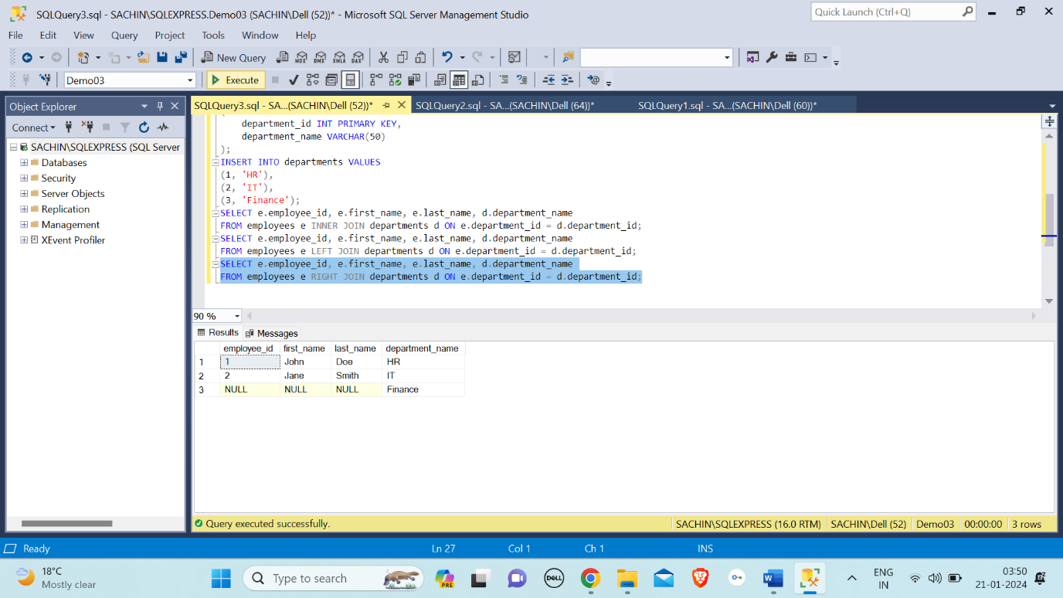

Full Join (or Full Outer Join): Returns all rows when there is a match in either the left or right table. If there is no match, NULL values are returned for columns from the table that doesn't have a match.

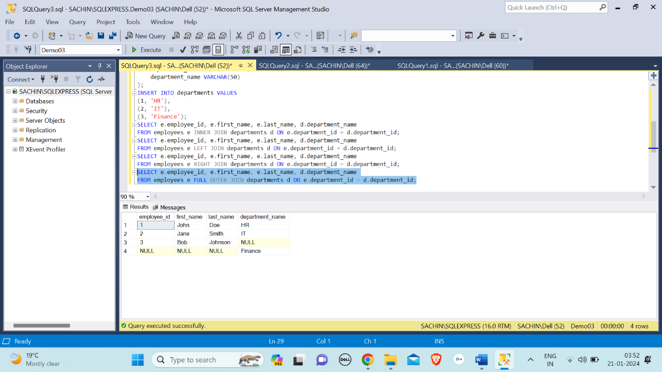

**OPERATORS:**

AND Operator: The AND operator is used to combines two or more conditions but if it is true when all the conditions are satisfied.

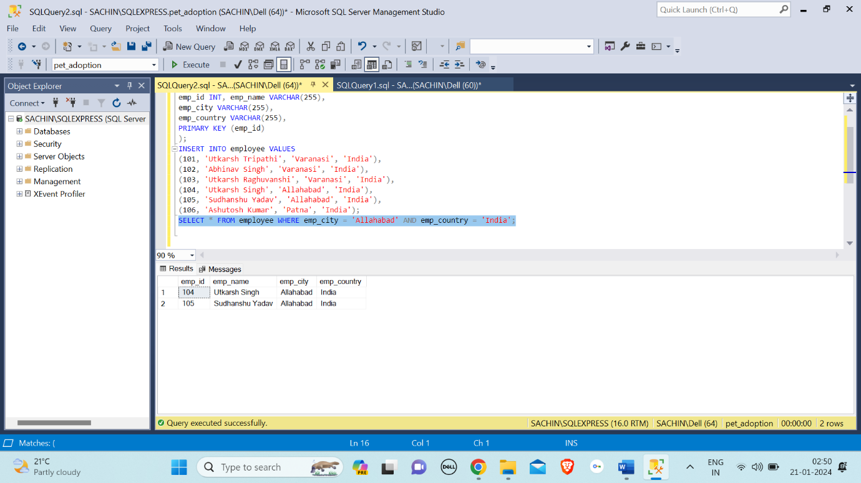

IN Operator: The "IN" operator in SQL is used to filter results by specifying a list of values, and it returns rows where a specified column's value matches any value in the provided list.

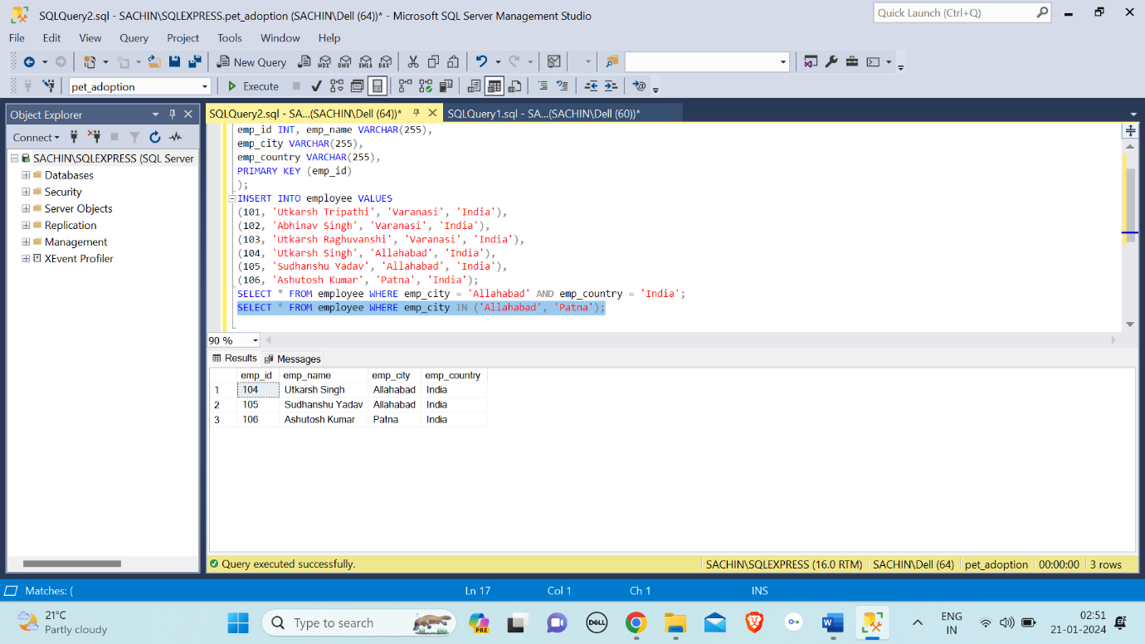

NOT Operator: The "NOT" operator in SQL is used to negate a condition, returning rows that do not satisfy the specified condition.

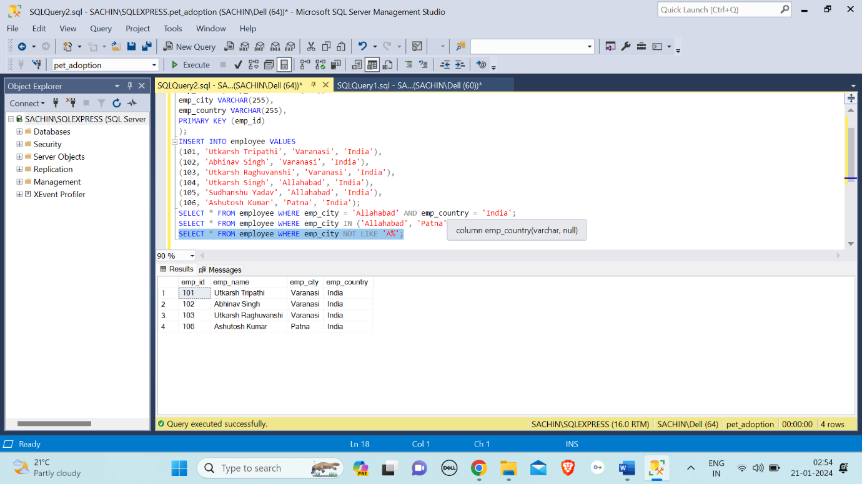

OR Operator: The OR operator is used to combines two or more conditions but if it is true when one of the conditions are satisfied.

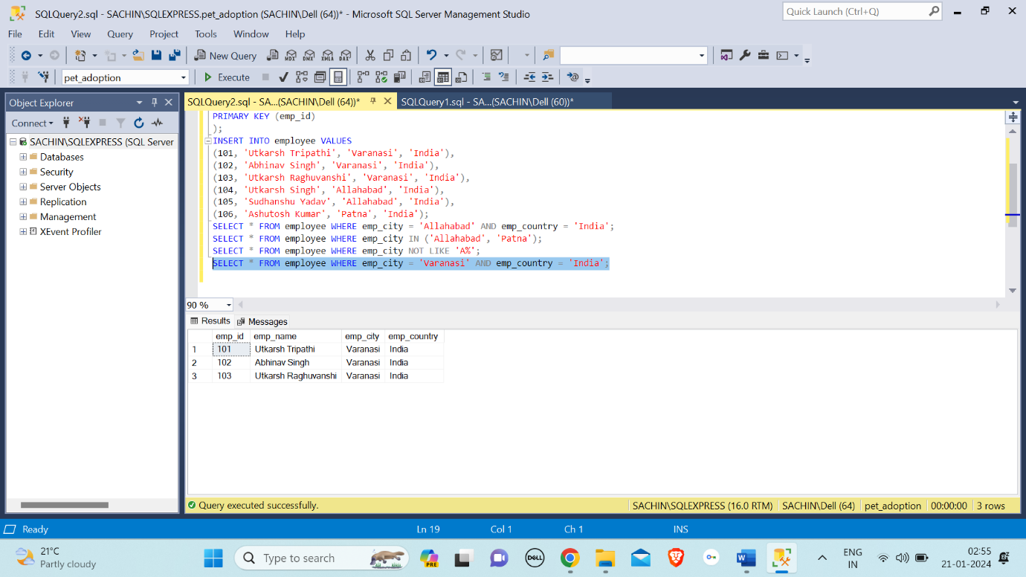

LIKE Operator: The "LIKE" operator in SQL is used to search for a specified pattern in a column, allowing the selection of rows that match the pattern.

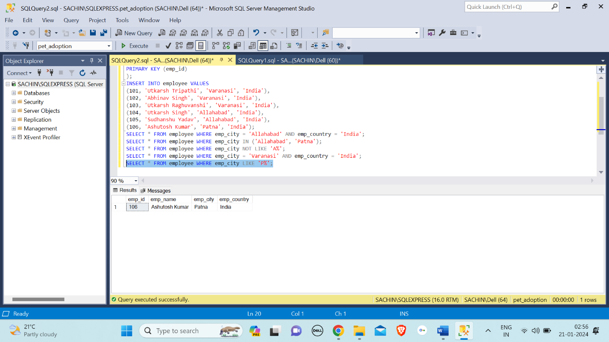

BETWEEN Operator: The "BETWEEN" operator in SQL is used to filter query results based on a specified range of values for a given column.

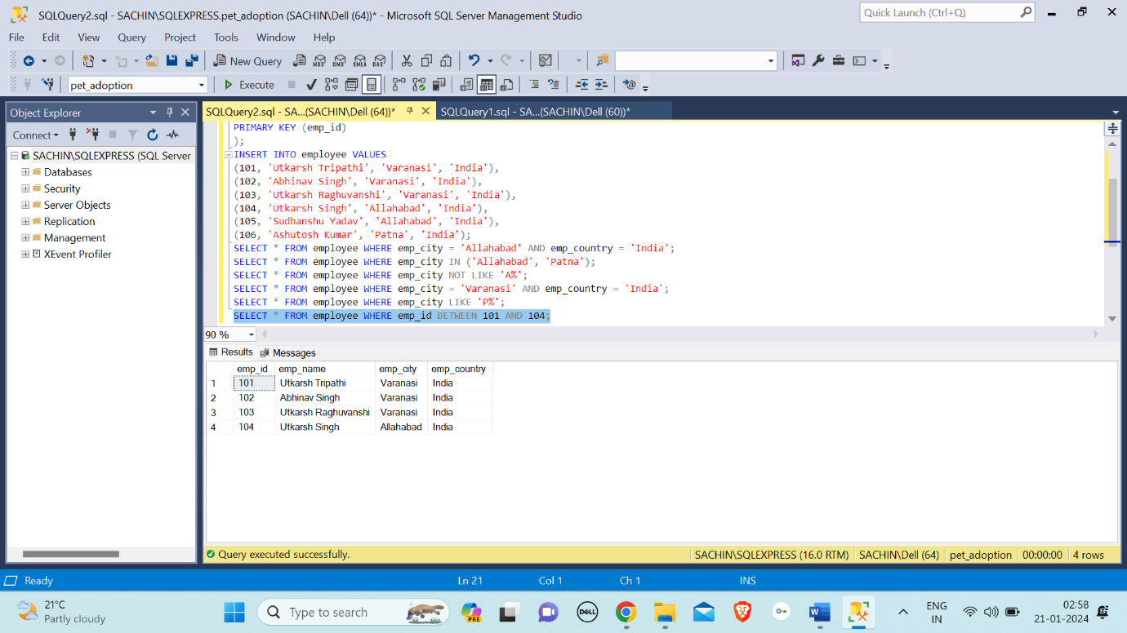

ALL Operator: The ALL operator returns TRUE if all of the subqueries values matches the condition. All operator is used with SELECT, WHERE, HAVING statement.

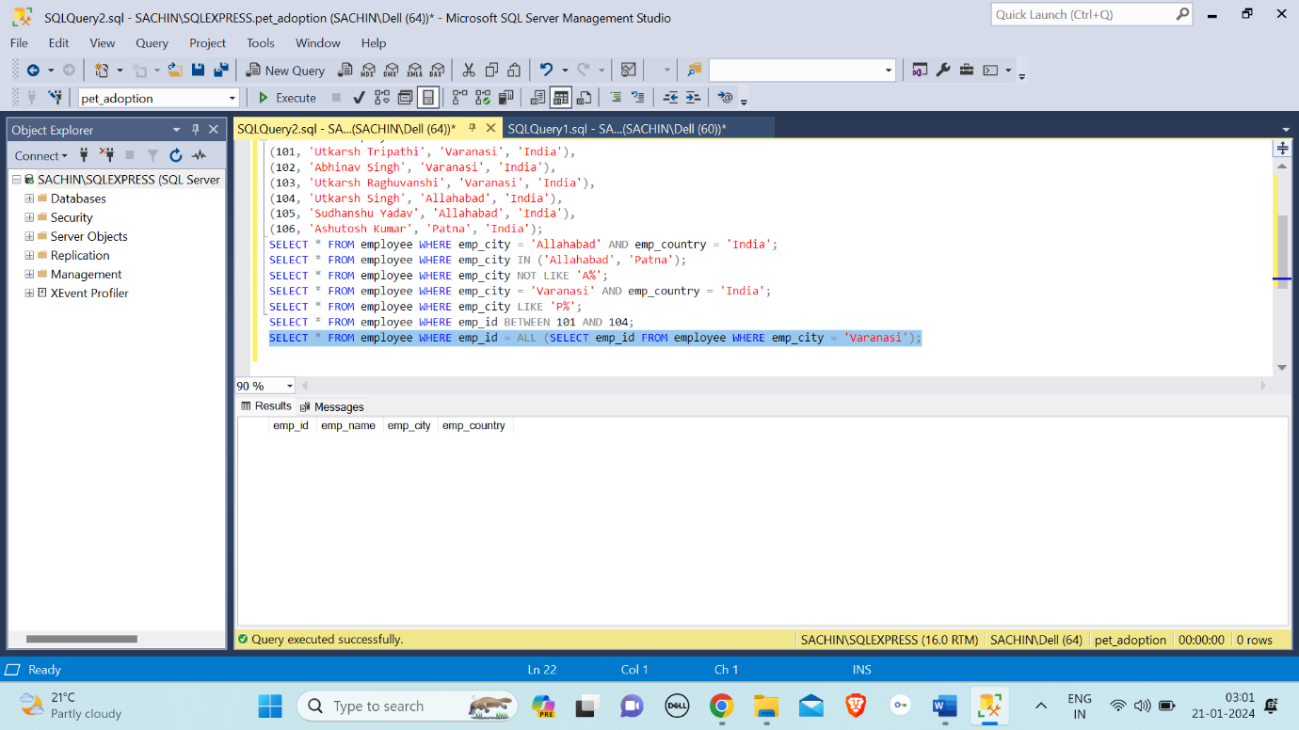

ANY Operator: The "ANY" operator in SQL is used to compare a value to any value in a set of results returned by a subquery.

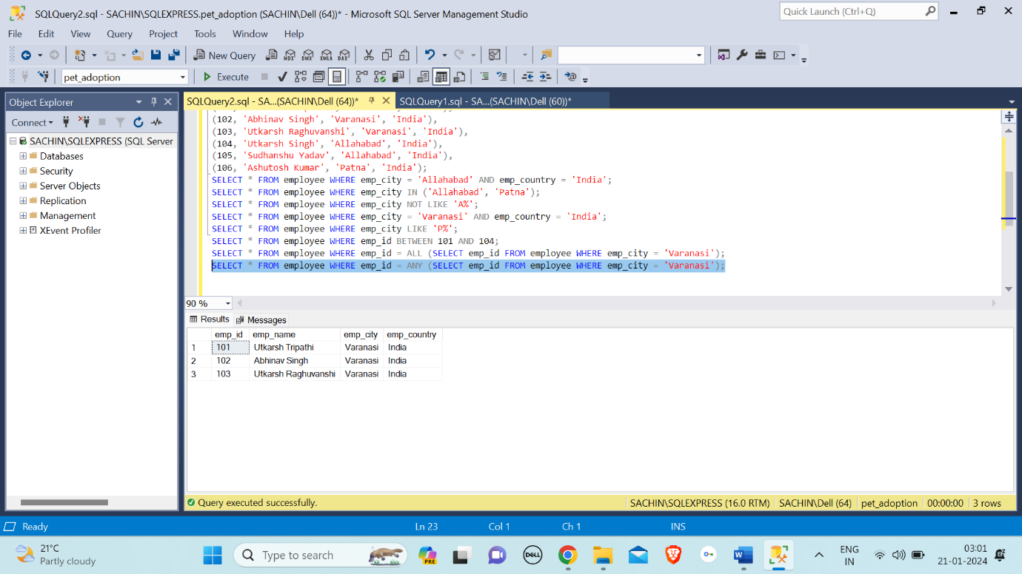

EXISTS Operator: The "EXISTS" operator in SQL is used to check whether a subquery returns any rows and returns a Boolean value (True or False) based on the existence of those rows.

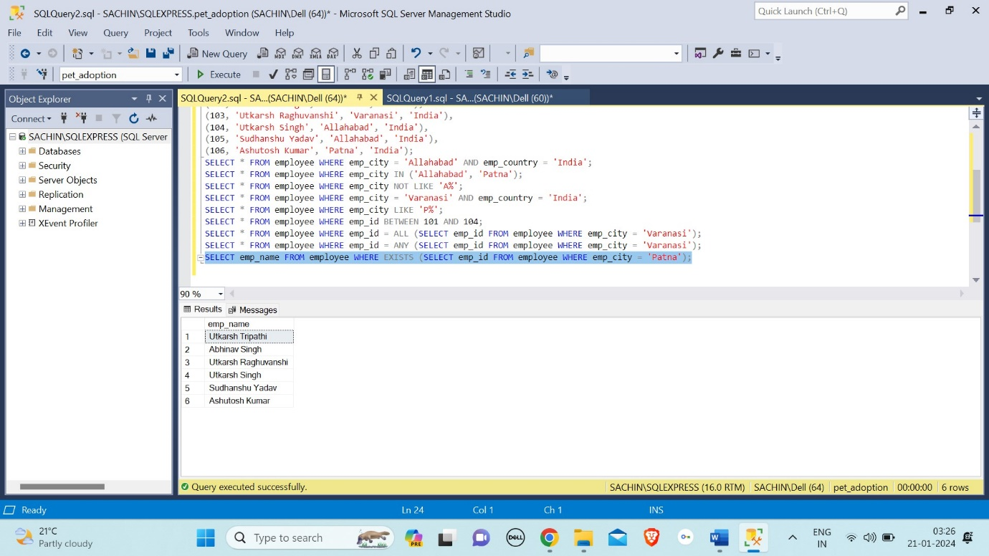

SOME Operator: SOME operators are issued with comparison operators (<,>,=,<=, etc) to compare the value with the result of a subquery.

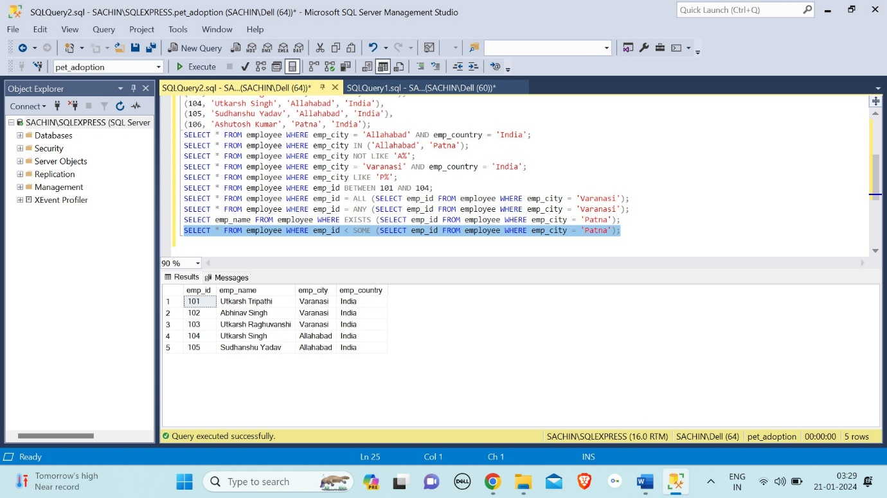

WHERE CLAUSE: The "WHERE" clause in SQL is used to filter records in a query based on specified conditions, allowing you to retrieve only the data that meets certain criteria from a table.

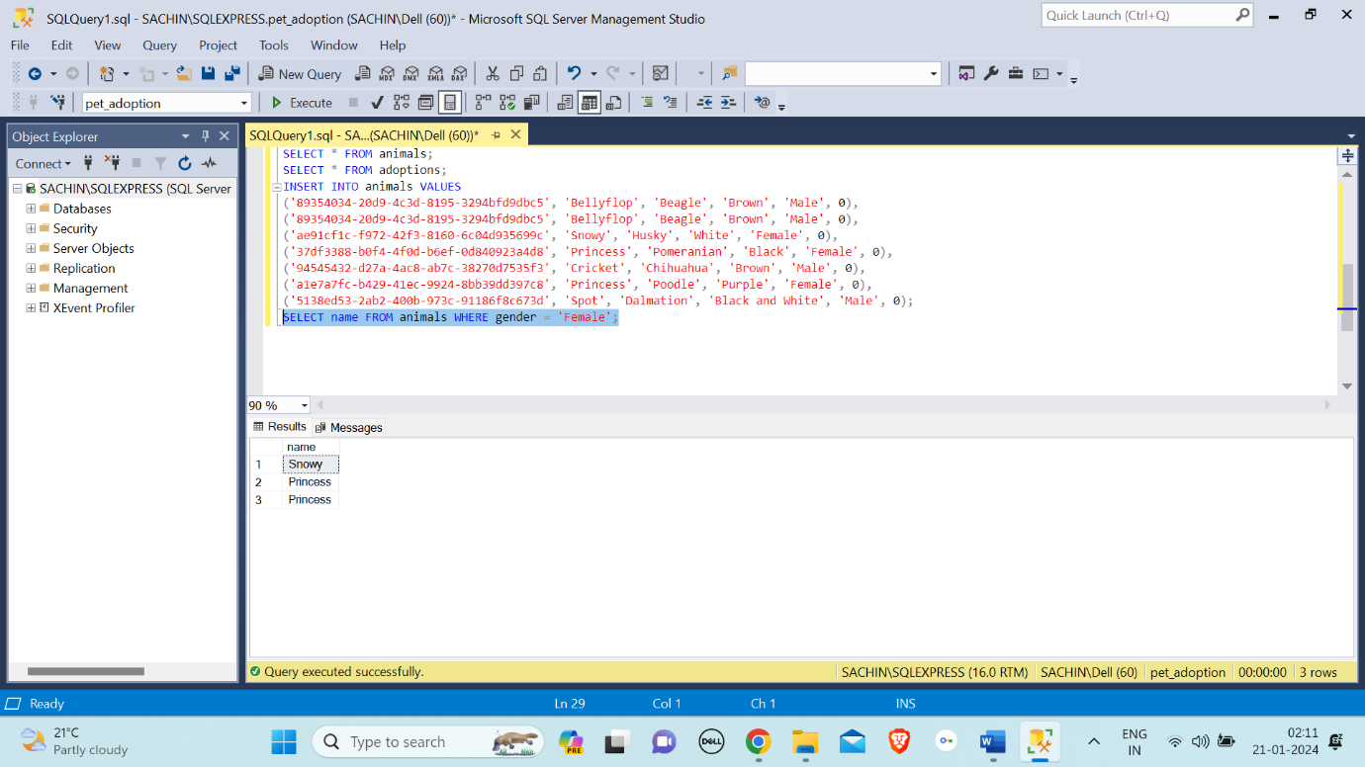

ORDER BY: The "ORDER BY" command in SQL is used to sort the result set of a query based on one or more columns in ascending or descending order.

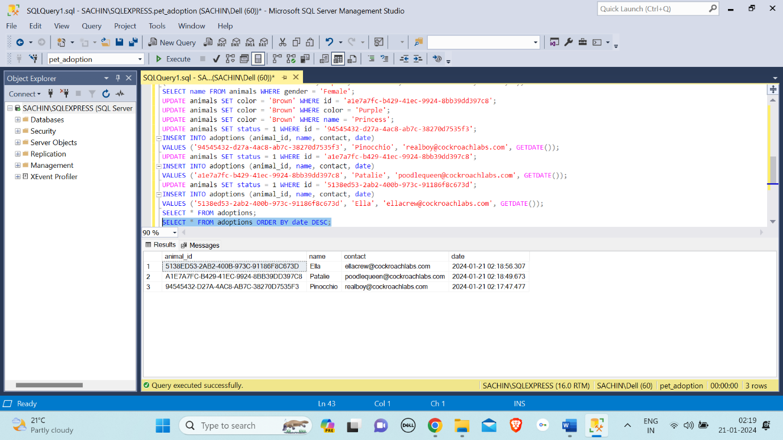

SET: The "SET" command in SQL is used to modify the session-level settings, such as changing the behaviour of the query optimizer or adjusting the display settings for result sets.

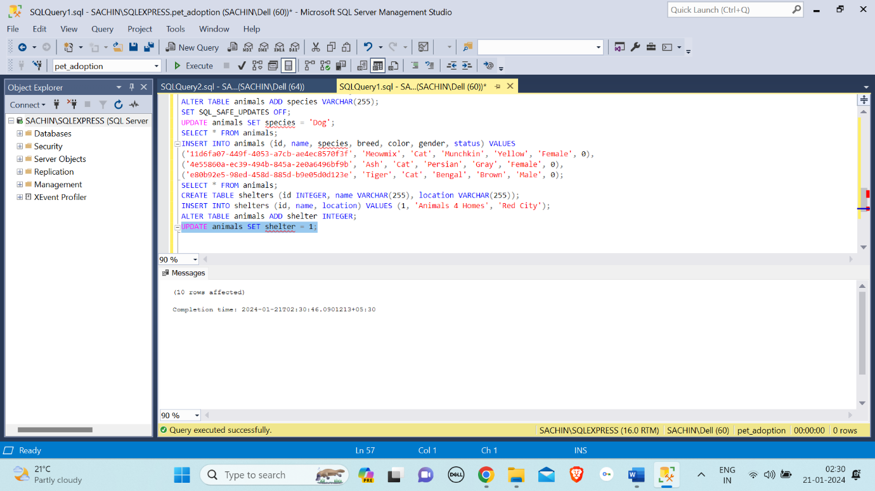

INDEX: The "INDEX" command in SQL is used to create an index on one or more columns of a database table, enhancing query performance by facilitating faster data retrieval.

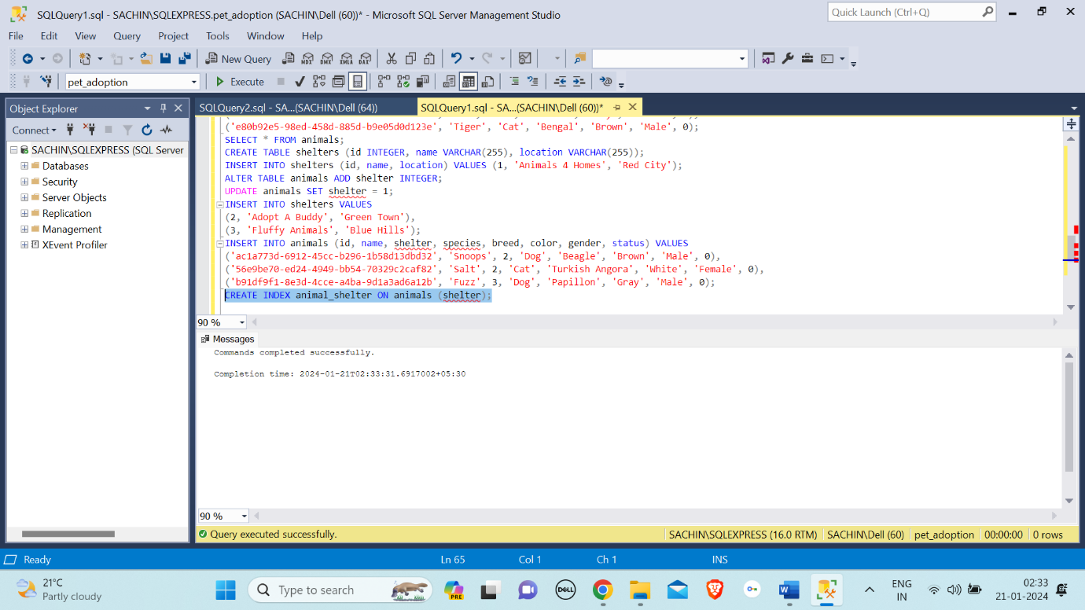

ON: In SQL, the "ON" command is primarily used in conjunction with clauses such as JOIN conditions to specify the criteria for combining rows from different tables.

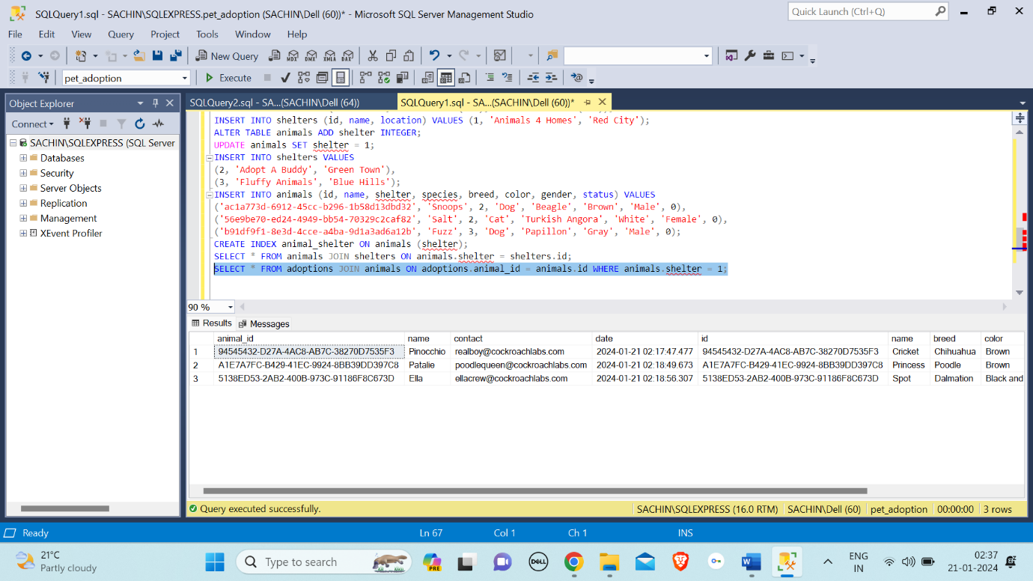

DISTINCT: The "DISTINCT" operator in SQL is used to retrieve unique values from a specific column in a result set, eliminating duplicate entries.

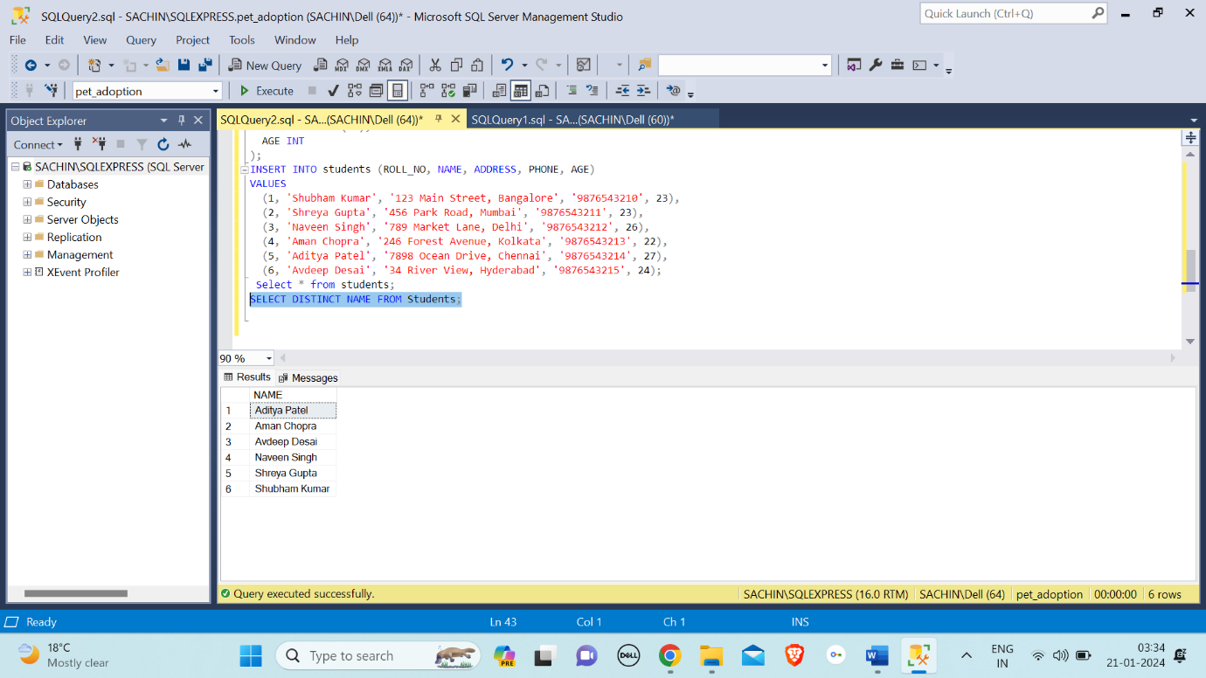

COUNT() Function: The "COUNT" operator in SQL is used to count the number of rows that meet a specified condition in a table or result set.

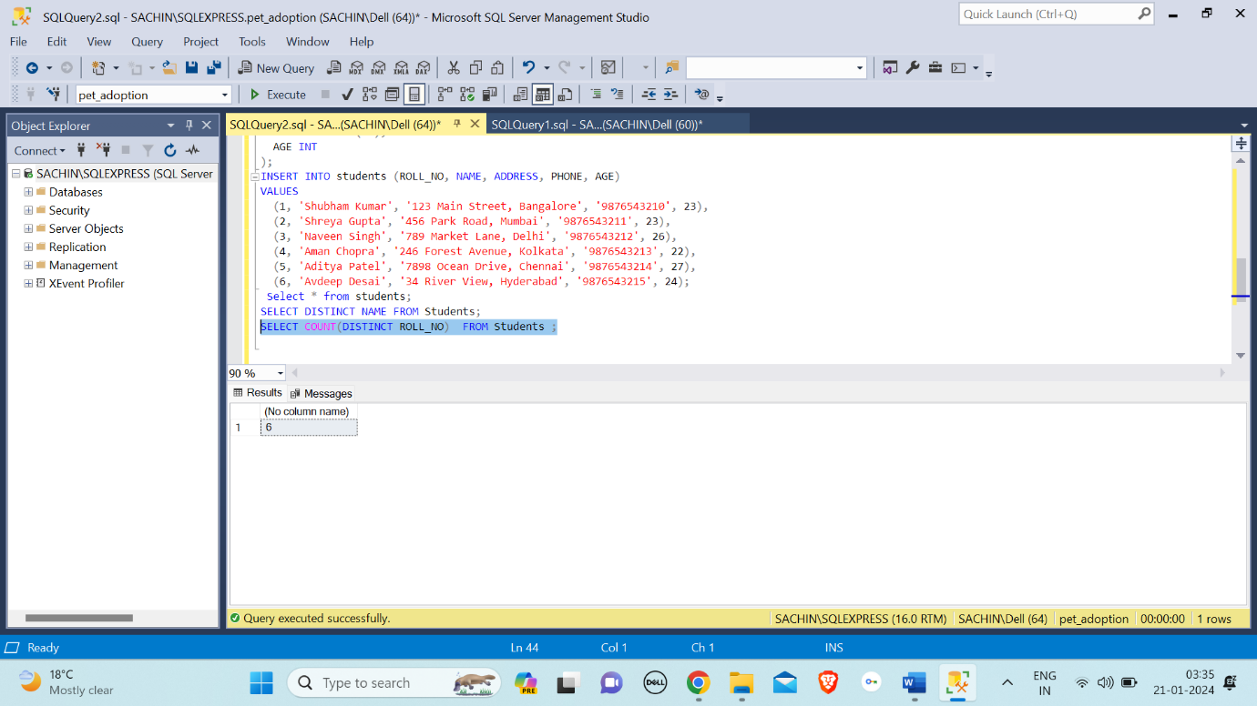

DELETE: DELETE in SQL is a command used to remove records from a table based on specified conditions, allowing for the targeted removal of data.

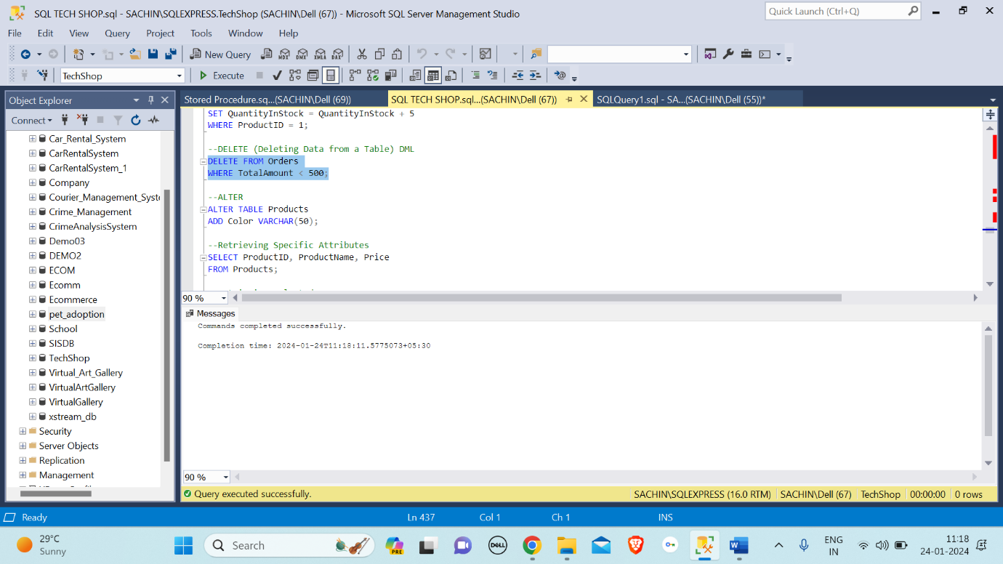

Column Aliases: Column aliases in SQL allow you to temporarily rename a column in a query result, providing a more readable or meaningful name for the output without altering the underlying database schema.

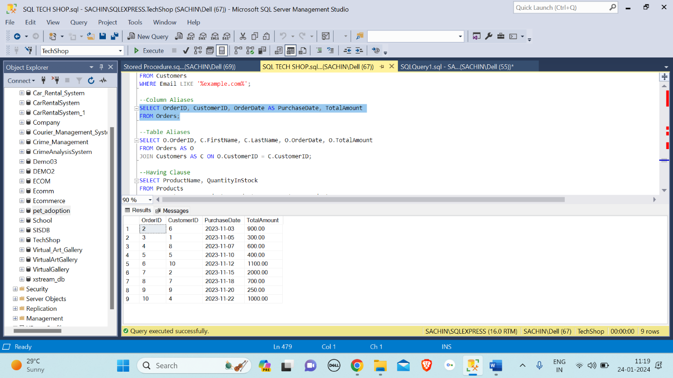

Table Aliases: Table aliases in SQL are shorthand names assigned to tables in a query, facilitating concise and readable code by allowing users to refer to tables with abbreviated identifiers.

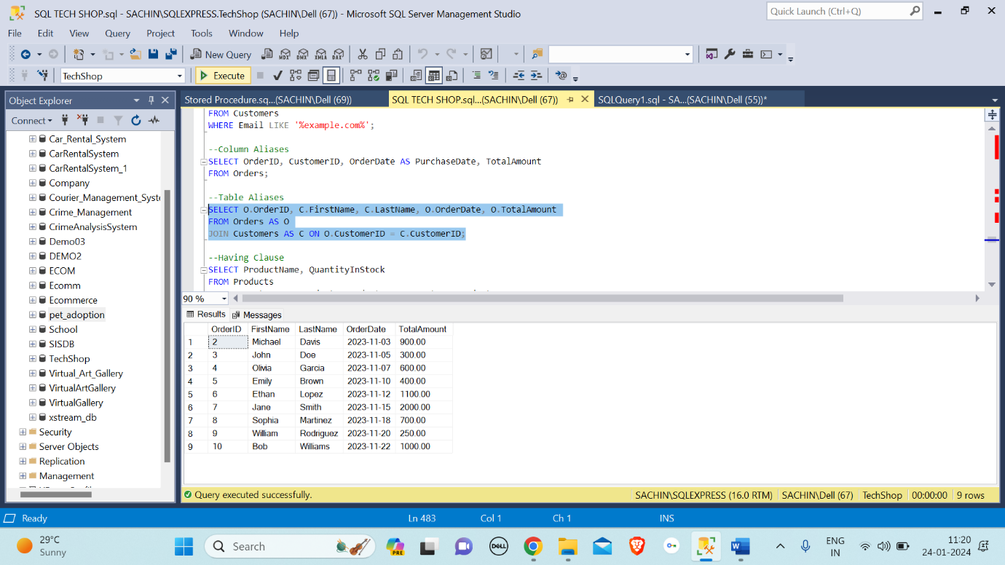

Having Clause: The "HAVING" clause in SQL is used to filter the results of a GROUP BY query based on specified conditions applied to aggregated values.

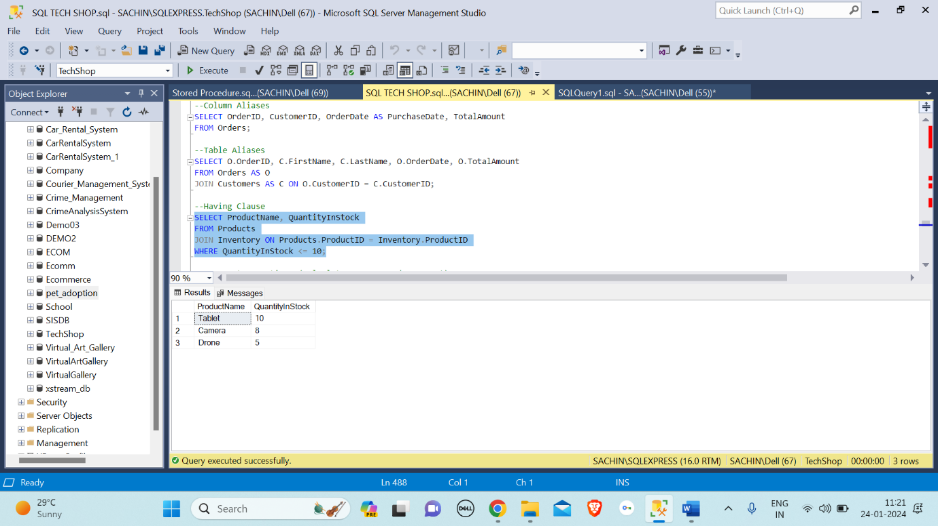

Aggregate Functions: Aggregate functions in SQL perform a calculation on a set of values and return a single result, summarizing or "aggregating" the data, commonly used with GROUP BY clauses.

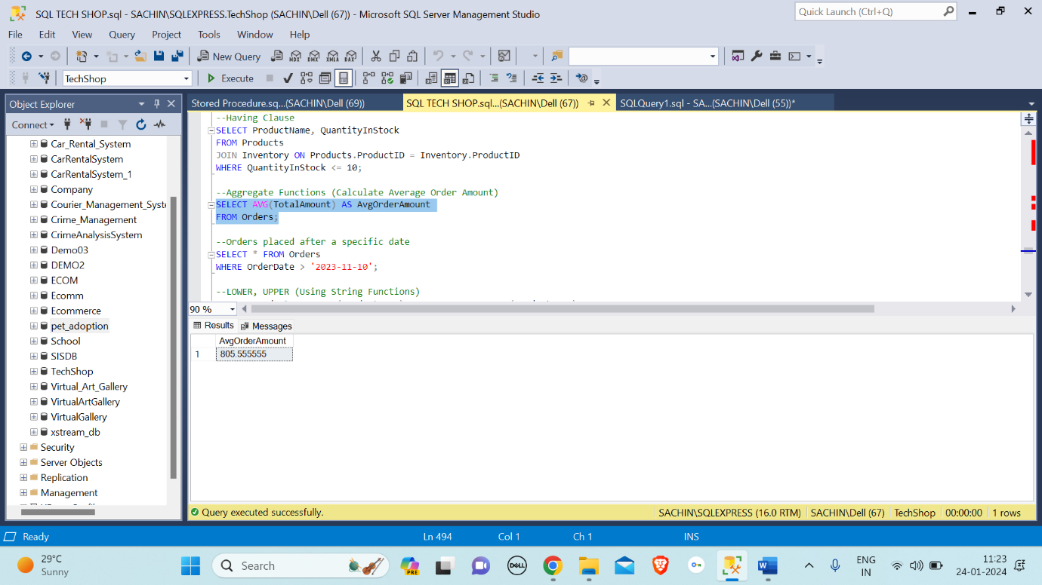

Date function: Date functions in SQL allow for the manipulation and retrieval of date and time-related information within a database, enabling operations such as date arithmetic, formatting, and extraction of specific components (e.g., day, month, year). In the below example states for orders placed after a specific date.

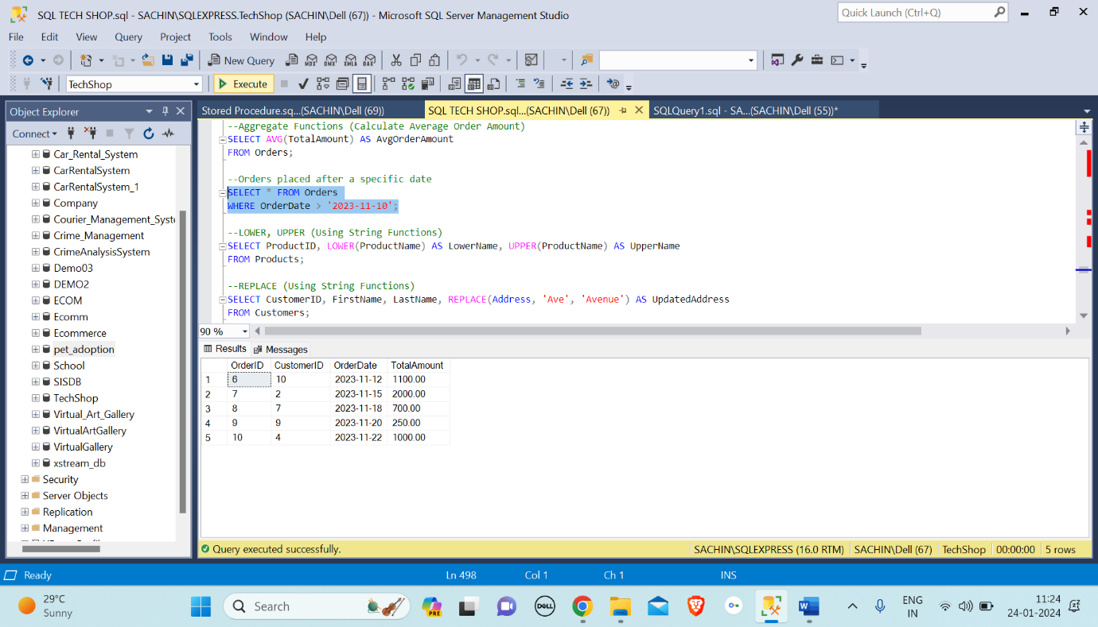

String Function: String functions in SQL are used to manipulate and perform operations on text data within a database, including tasks such as concatenation, substring extraction, case conversion, and pattern matching.

In the below string function example, In SQL, "LOWER" is a function used to convert characters in a string to lowercase, while "UPPER" is a function used to convert characters in a string to uppercase.

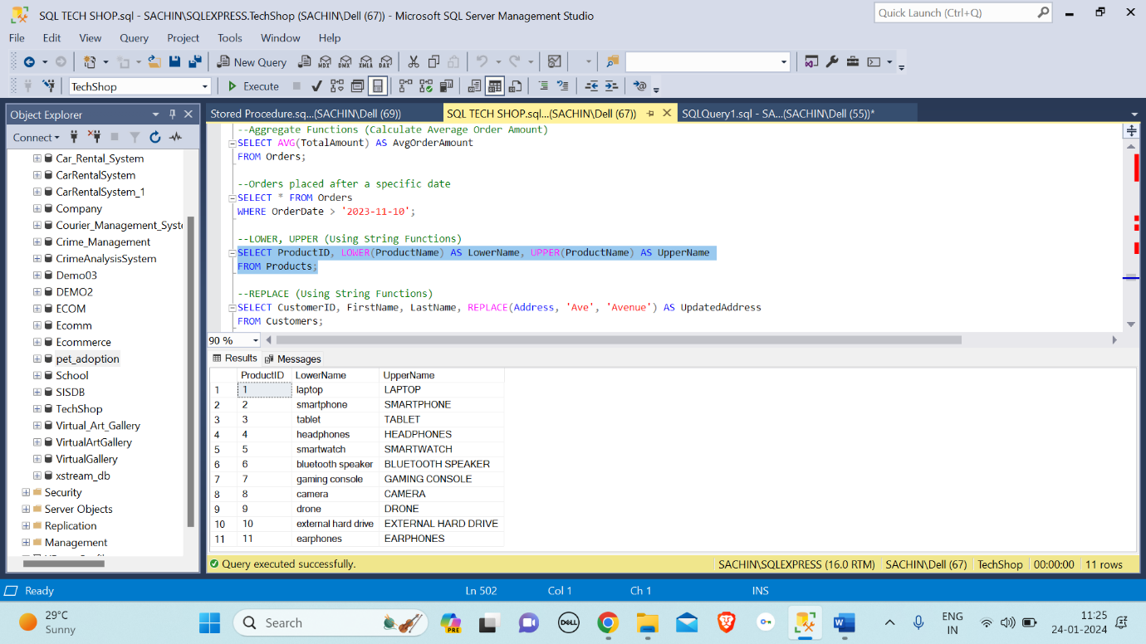

Replace: The SQL REPLACE function is used to replace occurrences of a specified substring with another substring in a given string.

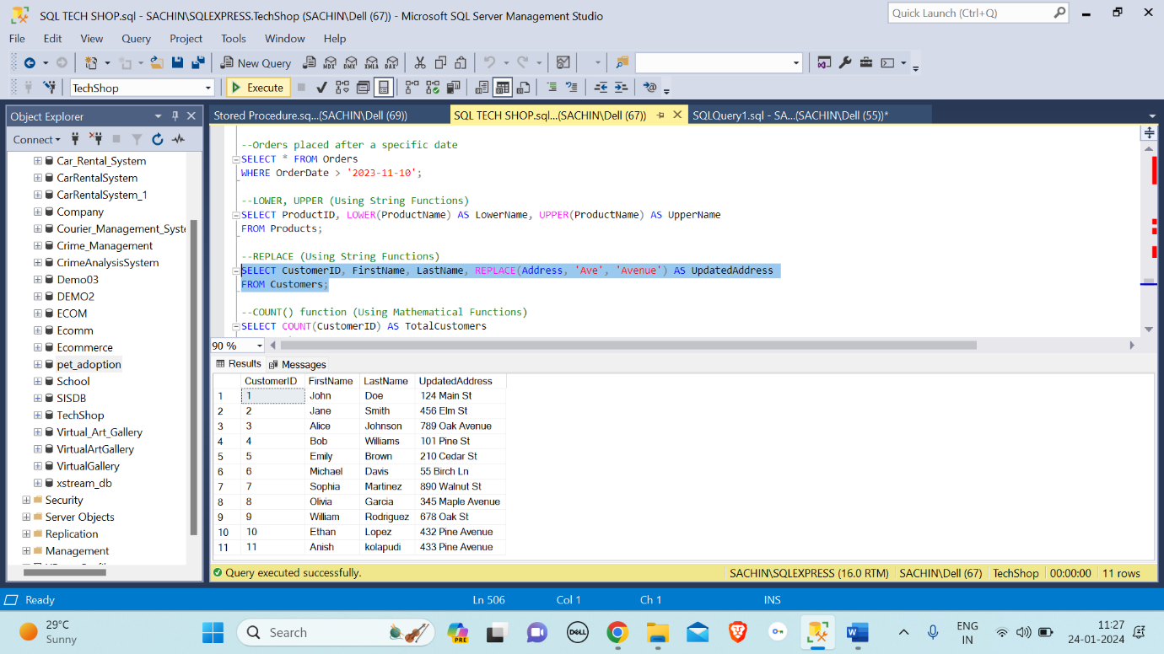

Mathematical Function: A mathematical function in SQL is a built-in operation that performs mathematical calculations on numeric values within a database query, facilitating tasks such as addition, subtraction, multiplication, division, rounding, and more.

Count() Function: COUNT() in SQL is a function used to determine the number of rows that satisfy a specified condition in a database table.

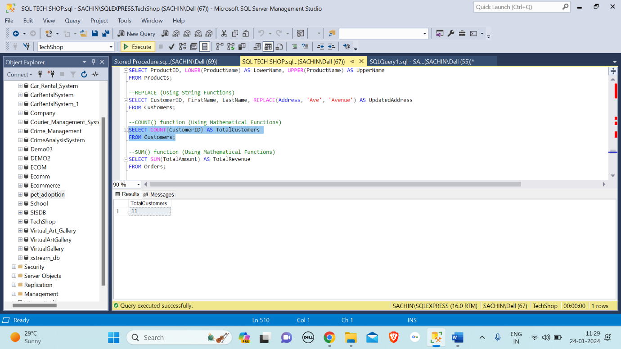

SUM() Function: The SUM() function in SQL is used to calculate the total sum of values in a specified column of a table.

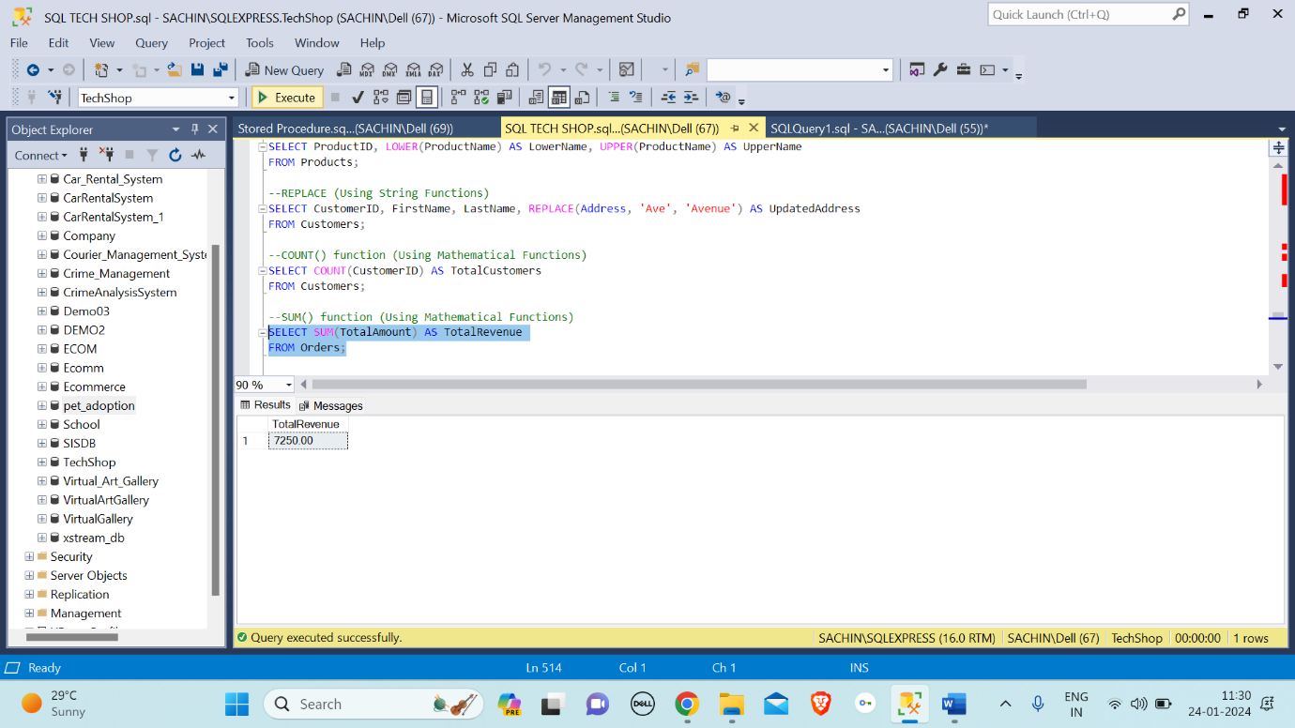

GROUP BY: GROUP BY in SQL is used to arrange identical data into summary rows, based on specified columns, often combined with aggregate functions to perform calculations on grouped data.

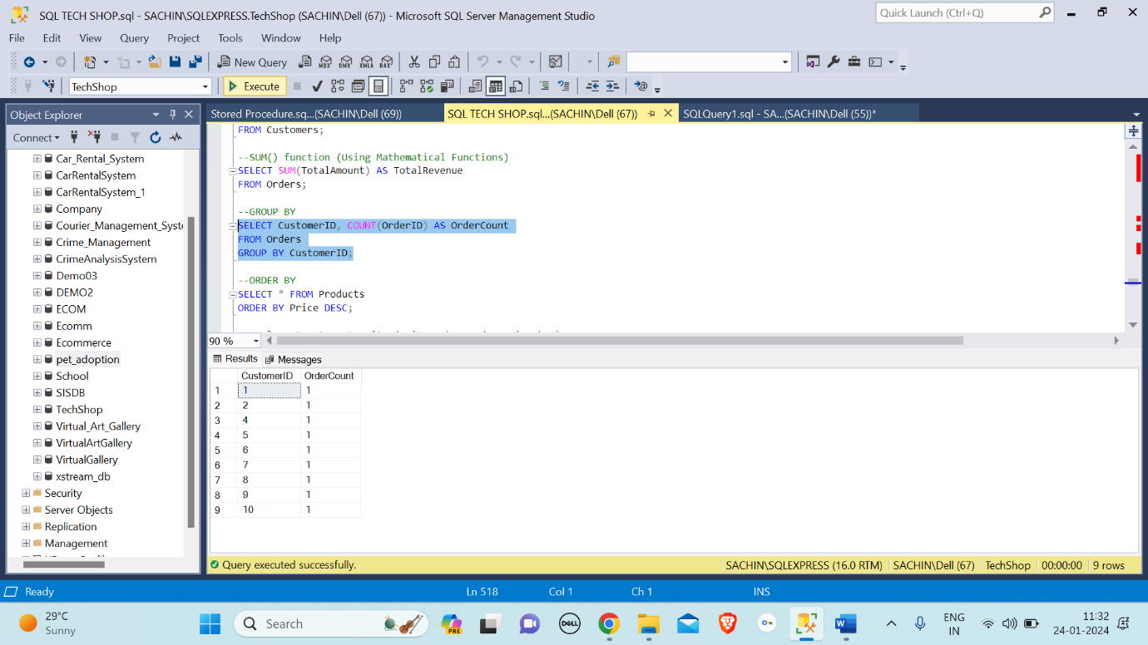

Cross Join: A cross join in SQL combines every row from two tables, resulting in a Cartesian product where each row from the first table is paired with every row from the second table.

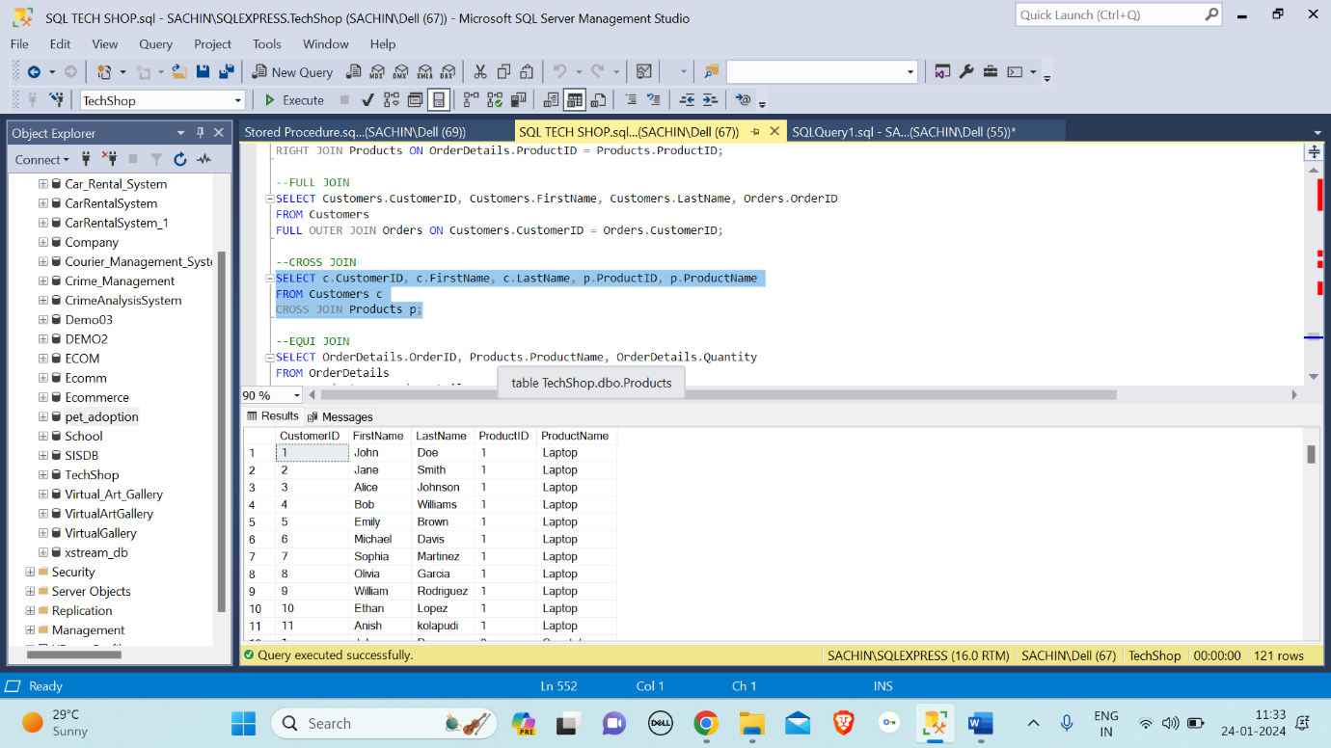

Equi Join: Equi Join in SQL is a type of join that retrieves rows from two tables based on the equality of values in specified columns, using the "=" operator.

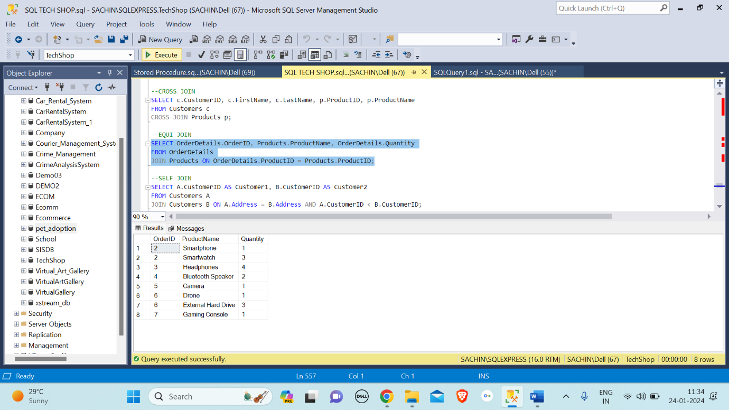

Self Join: A Self Join in SQL is a technique where a table is joined with itself, treating it as two separate instances, typically used to retrieve related information within the same table.

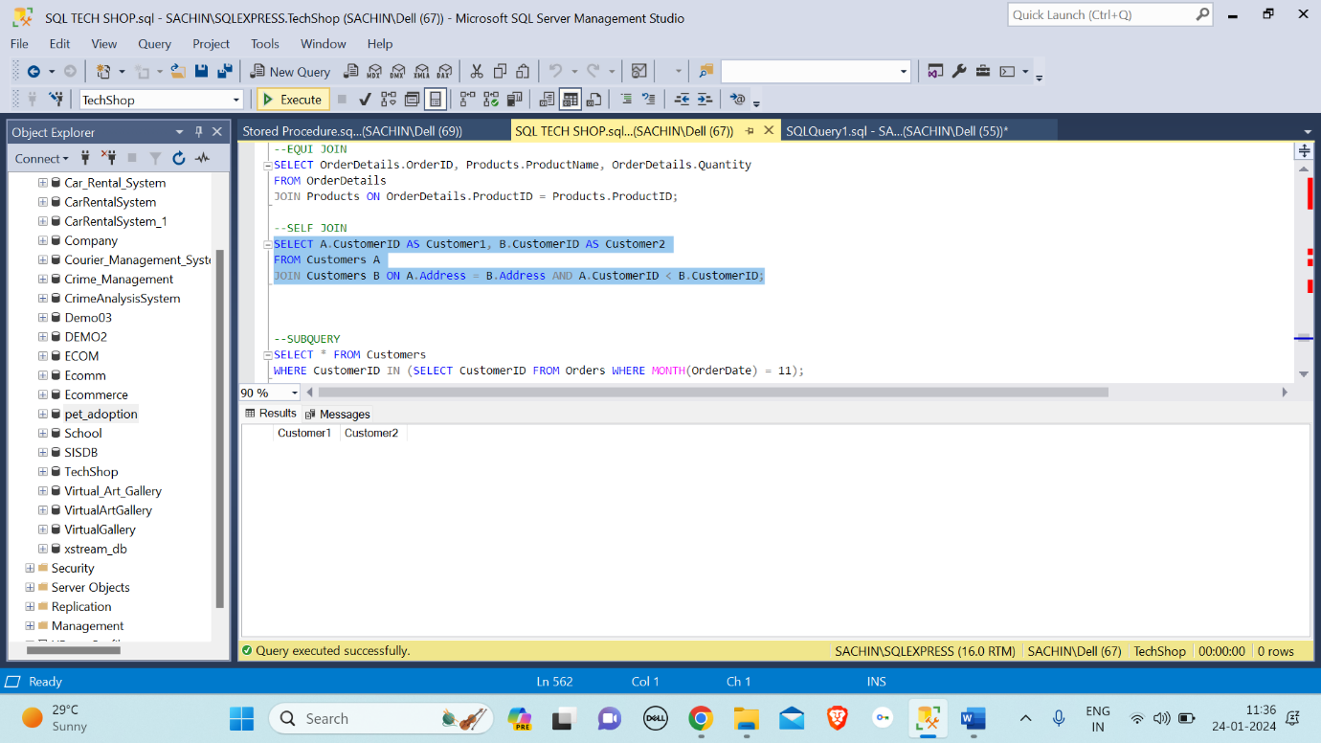

Sub-query: A subquery in SQL is a nested query that is embedded within another SQL statement, allowing the result of the subquery to be used as a condition or value in the outer query.

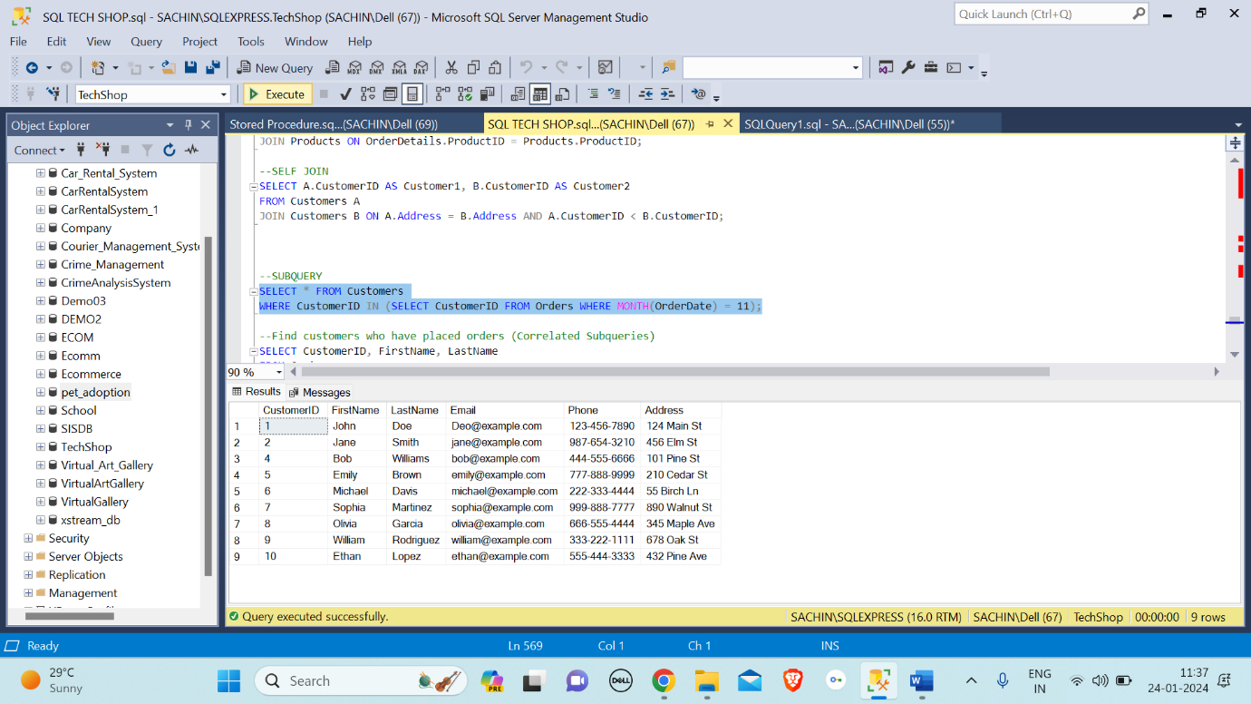

Correlated Subqueries: Correlated Subqueries in SQL are nested queries where the inner query depends on the outer query, allowing for referencing values from the outer query within the subquery for more complex and context-dependent data retrieval.

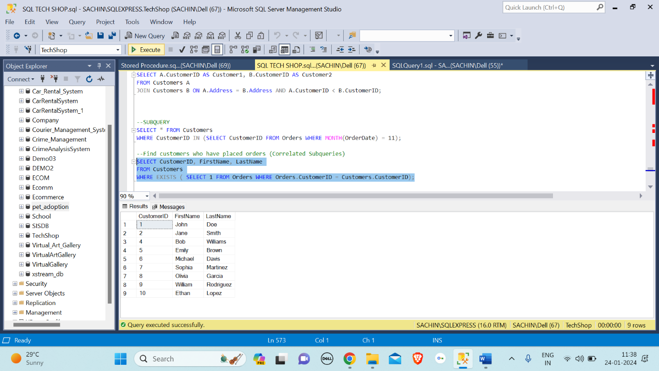

UNION: UNION in SQL is used to combine the results of two or more SELECT statements and retrieve distinct rows from the combined result set.

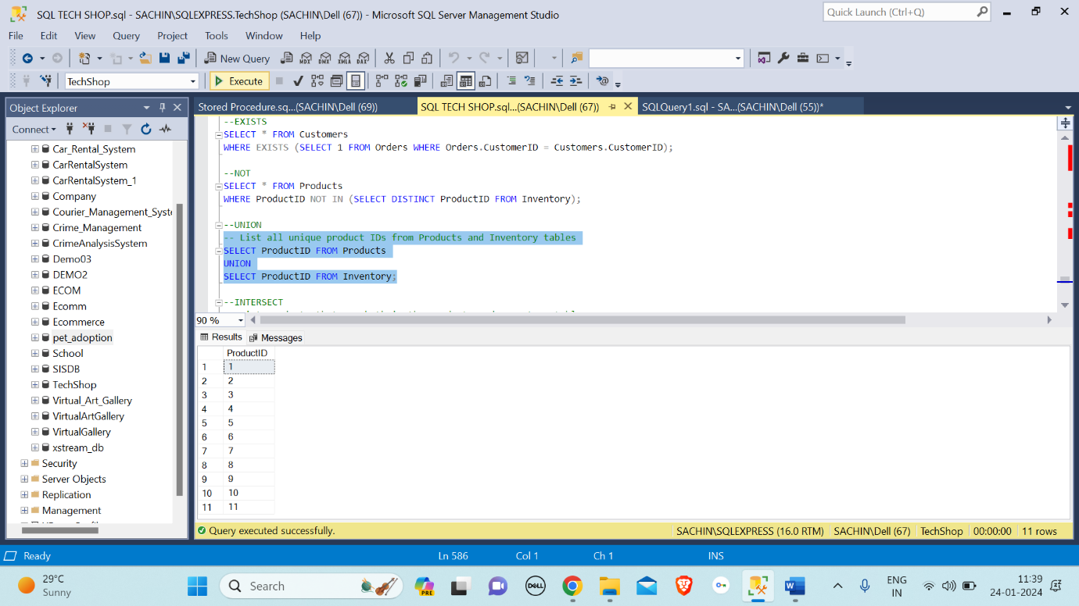

INTERSECT: INTERSECT in SQL is a set operation that retrieves common rows from two SELECT statements, returning only the shared results between the two queries.

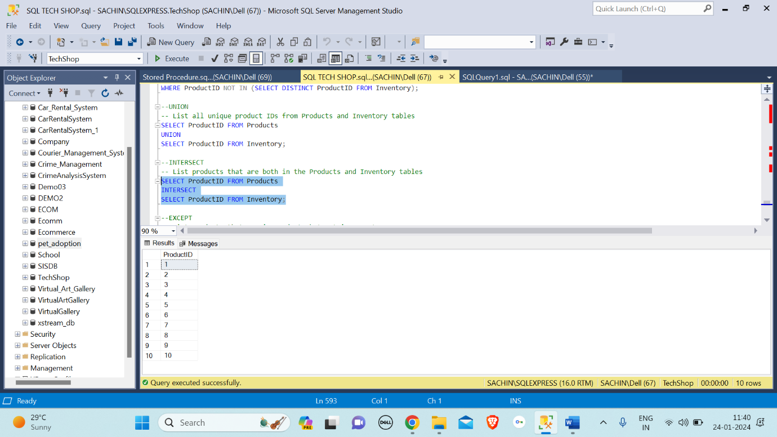

EXCEPT: EXCEPT in SQL is used to retrieve distinct rows from the result set of the first query that are not present in the result set of the second query.

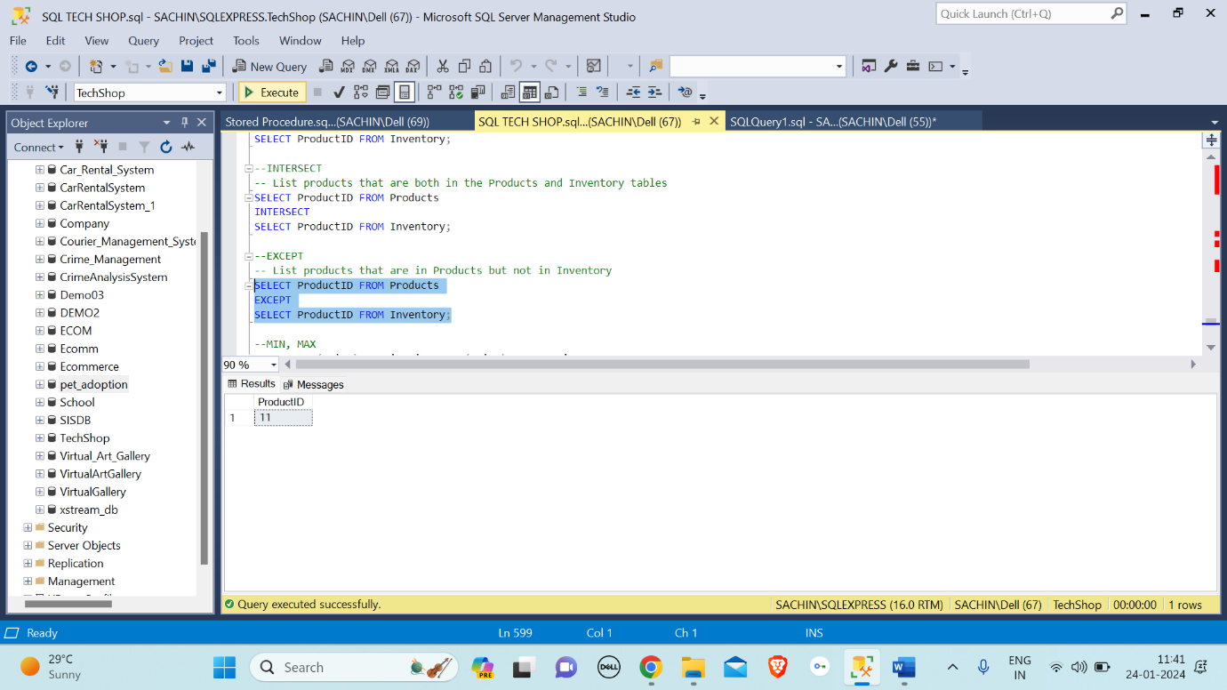

MIN and MAX: MIN and MAX are aggregate functions in SQL used to retrieve the smallest (minimum) and largest (maximum) values, respectively, from a specified column in a given set of rows.

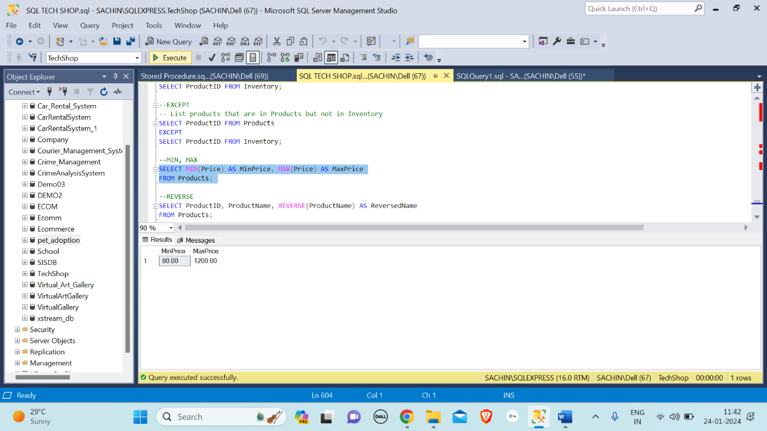

Reverse Function: In SQL, the "REVERSE" function is used to reverse the order of characters in a given string.

